“Taken by the Turkes”
Captivity, Ransom, and Conversion among Dartmouth Seafarers, 1620–1640
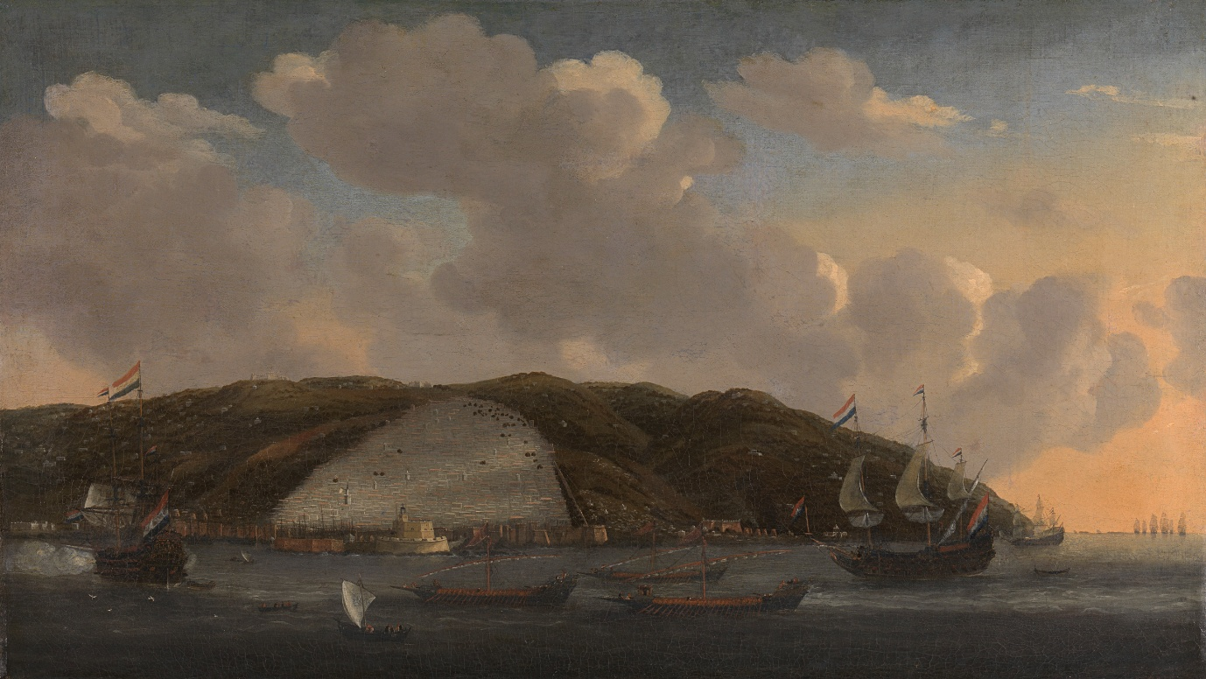
View of Algiers from the sea, mid 17th century

In the first of two talks on Dartmouth and slavery, Jonathan Turner examines the impact of Barbary corsair activity on South Devon – and on Dartmouth in particular – during the early 17th century. Through the stories of real, local seafarers, he explores what captivity and enslavement meant in the Maghreb states, and how being taken by the corsairs of Algiers, Tunis, and Salé shaped the lives of those who were captured, ransomed, or returned home transformed.
Local Speaker; Jonathan Turner – A welcome return after the informative talk he gave last year. Jonathan has a lifelong interest in history, is Chair of the SW Maritime history society, member of Dartmouth History Research group, Trustee of Dartmouth Museum, and a writer of historical articles.
“Collected for the releefe of three fishermen of this parish taken by the Turkes, the sum of 20s.”
Dittisham Churchwarden’s accounts, 1633

